Final Project Report
By: Nikolas Lee-Bishop and Quenten Masters

Within the United States, there has been an increase in the use of highly fuel-efficient cars over the past two decades. For this project, we hoped to explore several questions pertaining to fuel consumption and gas prices within the United States between the years 1995 and 2021. The first question we wanted to answer was: “As the number of fuel-efficient cars increases and the number of vehicle registrations decreases, will that affect the future fuel consumption across the United States of America?” Our second question was “Do Gasoline and Diesel prices within the U.S. move in similar trends? Can we predict the price of one based upon the other?”

To properly answer these questions, we used four different publicly available datasets. Including data sets from the U.S Energy Administration and Bureau of Transportation Statistics. These datasets provided us with information related to fuel consumption, vehicle efficiency standards, vehicle registration, and routine gas prices. These datasets were used due to them being updated regularly, produced by reliable sources, and ease of access.

What is the Effect of Vehicle Registrations and Fuel Efficiency on Gasoline Consumption?

Introduction:
In this analysis, we aim to see how fuel consumption changes over time based upon the historical trends of registrations and fuel efficiency. In the context of this question, registrations means personal automobiles such as cars, trucks, and motorcycles but also total of licensed drivers. Fuel efficiency is the average Miles Per Gallon of all cars across the country.

We would expect that over time, as the population of the country grows so does the number of registered vehicles and licensed drivers which should also relate to an increase of gasoline consumption. As technology improves we would also expect the average MPG of personal automobiles in the U.S. to improve, which if the number of automobiles remained constant, would show that consumption decreases. In our original proposal we had the idea of including how EV’s might have an effect on consumption, but we were unable to find a dataset that broke down the increase of EV’s over time.

Methodology:
For our dependent variable, consumption, we used the U.S. Energy Administration's ‘Product Supplied for Finished Motor Gasoline’ dataset. This dataset contains a column that has values for thousands of barrels of Finished Motor Gasoline supplied to U.S. gas stations every month. To get to a yearly value we just added up each month in every year. While not an exact measure of personal automobile gasoline consumption, we are using it as a proxy for gasoline consumption in personal automobiles. For our Independent Variables we have used two datasets from the Bureau of Transportation Statistics for vehicle registrations and fuel efficiency. The fuel efficiency dataset had MPG’s for 6 different vehicle types that we combined together and took the mean value of for each year. While this isn’t a precise way to calculate the average since the distribution of vehicles probably isn’t even, we couldn’t find a dataset that explored that distribution and it was necessary to reduce the number of inputs. The vehicle registrations dataset contained 3 columns, automobile registrations, motorcycle registrations, and licensed drivers. We decided to create a 4th column called total registrations which combined automobiles and motorcycles but we ended up not using it since licensed drivers performed better in our models.

Once we had cleaned all the datasets and merged them together, we tried multiple methods to find the best model. We started with a correlation matrix to see which variables were best correlated with consumption, they ended up being Licensed_Drivers, Motorcycle_Registrations, and AvgFuelEconomy. We observed that most vehicle categories were highly correlated with one another and that AvgFuelEconomy was highly correlated with them as well. Based upon the correlation matrix we used Licensed_Drivers as our form of vehicle registrations, and AvgFuelEconomy as our form of fuel efficiency. We started off with a Multiple Linear Regression model that was easy to interpret however it performed badly in terms of R². We then moved to Principal Component Analysis for dimensionality reduction but the model still performed poorly, likely due to multicollinearity. We then tried a Walk-Forward Validation w/ XGBoost which is better for time series prediction. This model performed significantly better in terms of R² . Then we attempted to use GridSearch models with XGBoost and they had a similar performance. The model that performed the best was the Full GridSearch w/ XGBoost. It was able to explain the most variance in gasoline consumption at 85.49% and had the lowest RMSE at 2,361.63. We also had originally stated we were going to use data until 2021, but when attempting to run models using 2021 as the end we, our models performed horribly due to the outliers created by COVID, so we have used 2019 as our end date.

Data Analysis and Results:
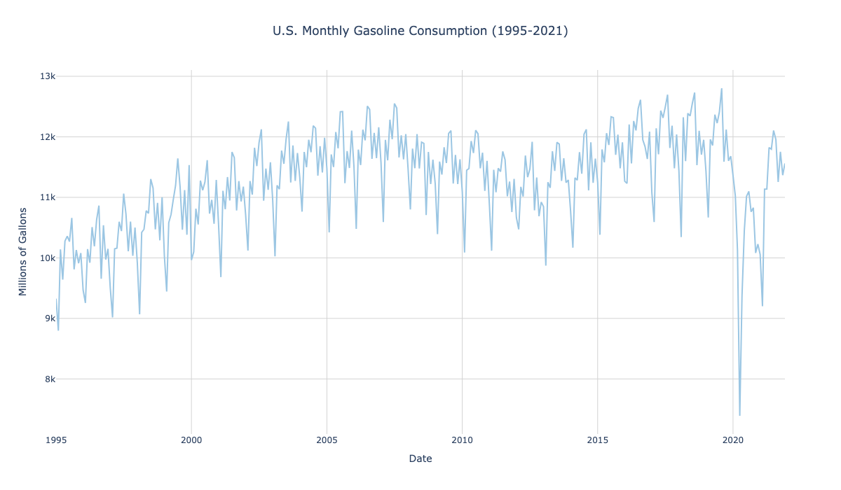
Fuel Consumption (‘95-’21): Fuel consumption doesn’t remain constantly positive

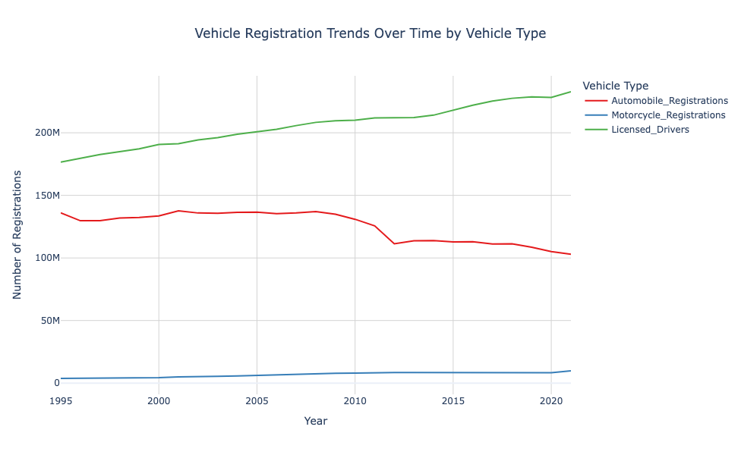
Vehicle Registrations (‘95-’21): Automobile registrations have declined over time while licensed drives have continually increased
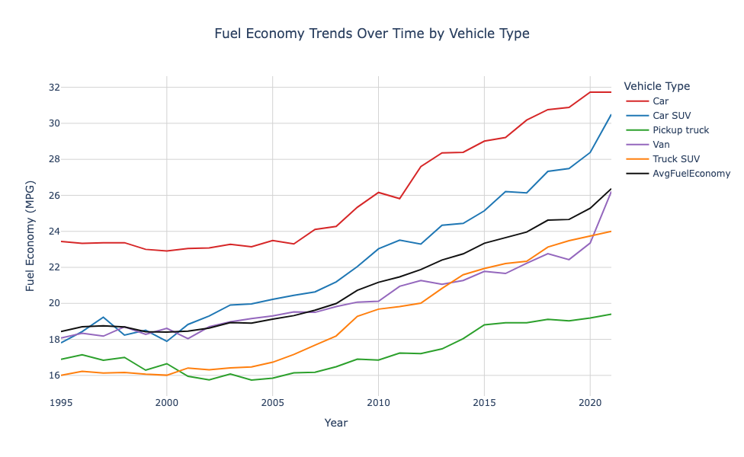
Fuel Economy:’95-’21): Fuel economy has generally increased over time. The black line represents the mean average of the 5 vehicle types. There is no form of weighting on it.

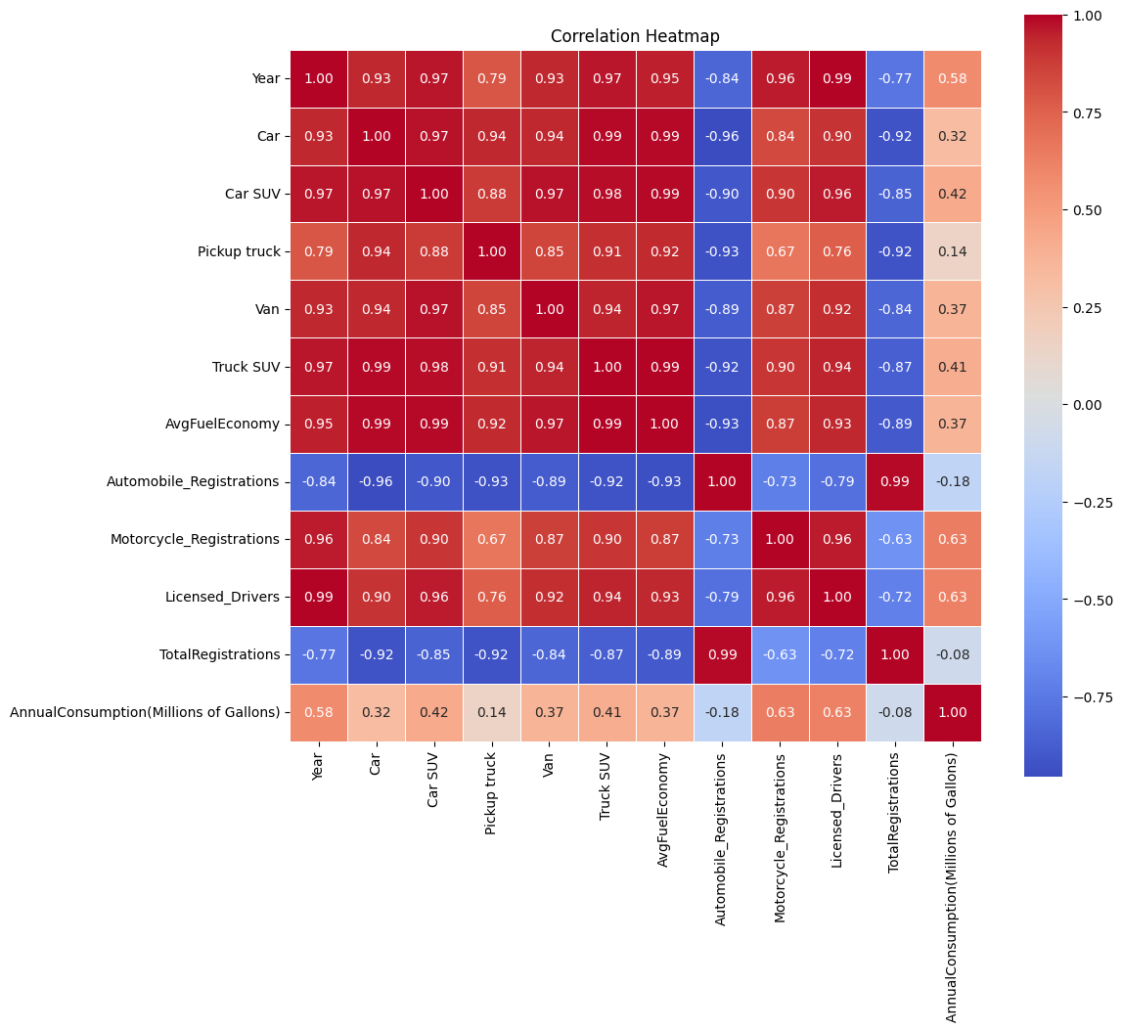
Correlation Matrix: Licensed_Drivers and Motorcycle_Registrations are highly correlated. Most vehicle categories are highly related to one another and AvgFuelEconomy since AvgFuelEconomy is derived from them.

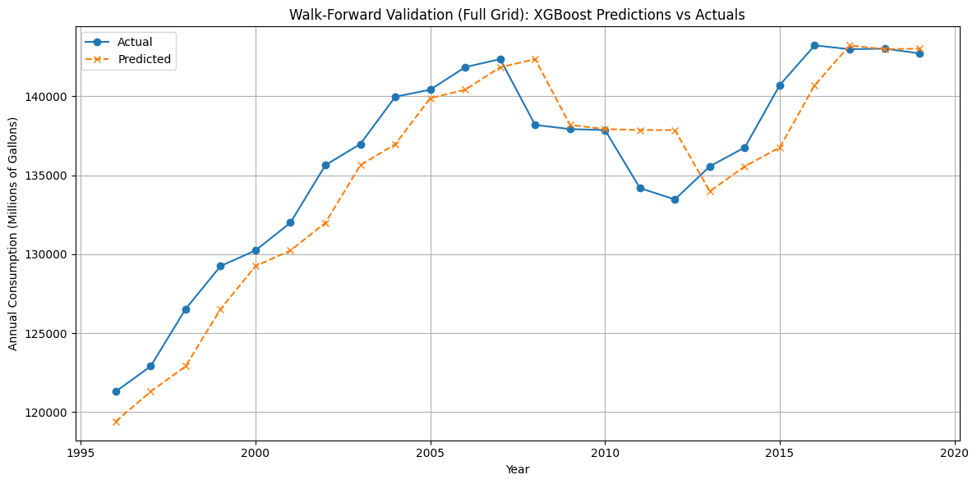
Chart showing the actual vs predicted rate for gasoline consumption using Licensed_Drivers and AvgFuelEconomy as the predictors for a Walk-Forward Validation mode with a full GridSearch and XGBoost.

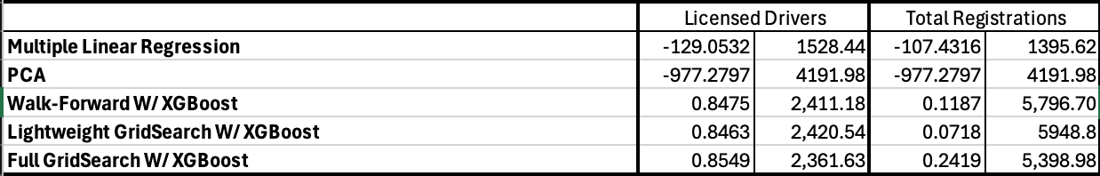
Chart comparing the use of Licensed_Drivers VS Total_Registrations and their models out performance metrics.

Link to GitHub for the Question 1 Notebook with the code, charts, and outputs

Discussion:
The results of our analysis revealed several interesting insights about the relationship between vehicle registration, efficiency, and gasoline consumption. The strongest predictor of gasoline consumption was the number of licensed drivers, not the number of vehicle registrations. This is interesting for a few reasons. You’d expect there's some relation to the two and that they’d move somewhat similar but this was not the case. While licensed drivers went up, vehicle registrations went down. You would also think that vehicle registrations would be better correlated to consumption since it's more closely related to the number of vehicles on the road.

An assumption we had made before testing that was validated was that as fuel efficiency went up, consumption tends to decrease. This makes sense, since you can go farther on a single tank and don’t need to refill as often over a longer period of time.

Model-wise, traditional and simpler methods performed worse, likely due to high multicolinearity between variables and the time series nature of the data. Using XGBoost models with grid search were the best at providing accurate predictions. The best R² value we got was 0.8549 and the best RMSE was 2,361.63. The model effectively captured temporal trends, nonlinear relationships, and effects between licensed drivers and fuel efficiency. Using the visualization you can see how well it predicts gasoline consumption. We did attempt to use the 2021 data like we had originally proposed but due to covid the normal trend lines were disrupted and the models could not perform well. From this analysis we can confidently conclude that fuel efficiency and licensed drivers do have an effect on gasoline consumption.

What is the relationship between Gasoline Prices and Diesel Prices? Do they move in similar trends?

Introduction:
The second question for our final report explored the relationship between the average monthly cost of retail Gasoline and retail Diesel between 1994 and 2021. We wanted to observe and describe any relationship the two fuel types followed over the set timeframe. In order to answer this question we used a dataset from the U.S. Energy Administration that collects monthly average prices for all grades of gasoline and diesel sold within the United States. Within this data set we found the average price of retail gasoline and the average price of retail diesel, which are the most important variables needed to answer our question.

The reason we wanted to explore this question was to determine if diesel was a practical alternative to gasoline when it comes to price. Gasoline is an essential good used by many individuals across the United States. Diesel is an essential good used primarily by trucks and semi-trucks. So while not used interchangeably, we expect that the two fuel types will have a strong correlation and follow a very similar pattern since they both react to the same economic and political factors.

Methodology:
To answer this question, we used the US Energy Administration's ‘Gasoline and Diesel Retail Prices’ dataset. This dataset contained 15 columns of different variations of gasoline or diesel variations and mixes. We removed all but 3 columns; ‘Date’, ‘US All Grades All Formulations Retail Price’, and ‘US No. 2 Diesel Retail Price’. To match our previous questions date range, we filtered the data from 1995 to 2021. After this we checked the skew and kurtosis of gasoline and diesel. Both datasets had skews ~0.14 which meant they were symmetric and kurtosis of ~ -1.14 which meant that they had flatter peaks than a normal distribution. After checking the statistical properties of the two columns we decided to adjust the dataset for inflation using the Federal Reserve’s CPI dataset.

After cleaning and transforming the data we moved onto visualizing the trends between the two. The first visualization was a simple line chart that compared the price of gasoline and diesel. From this we discovered that on quick glance, it seemed they had nearly the same price and moved in the same direction. Next we ran a correlation test and found that there was a 97.27% correlation between gasoline and diesel prices. Following that we used a linear regression model and plot and found that 94.63% of the variance could be explained. Then we calculated the absolute difference between the two and found that for 87.04% of months, the prices were within 5% of each other. To help visualize that we created a heatmap that showed each month for each year and color coded the absolute difference. Finally, we calculated the month to month change for gasoline and diesel prices and checked to see if it was positive or negative. From that we discovered that for 69.14% of months the prices moved in the same direction. Once we had all our charts and stats, we assembled them together in a dashboard.

Data Analysis and Results:

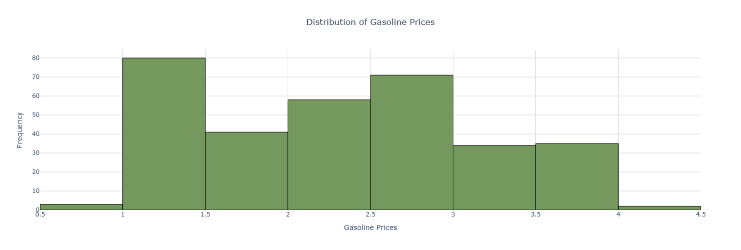
Histogram showing the distribution of Gasoline Prices. Binwidth was set to ($.50).

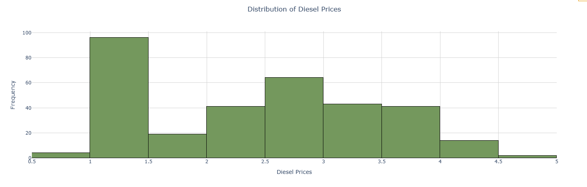
Histogram showing the distribution of Diesel Prices. Binwidth was set to ($.50).
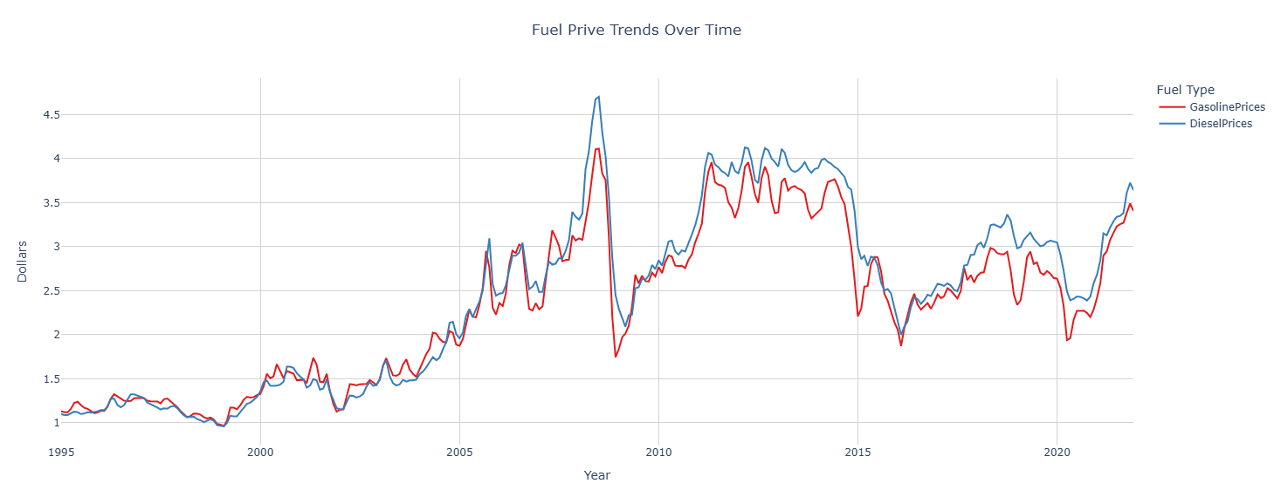
Line Plot showing Gasoline and Diesel Prices over time. The data starts in January of 1995 and goes until December of 2021.

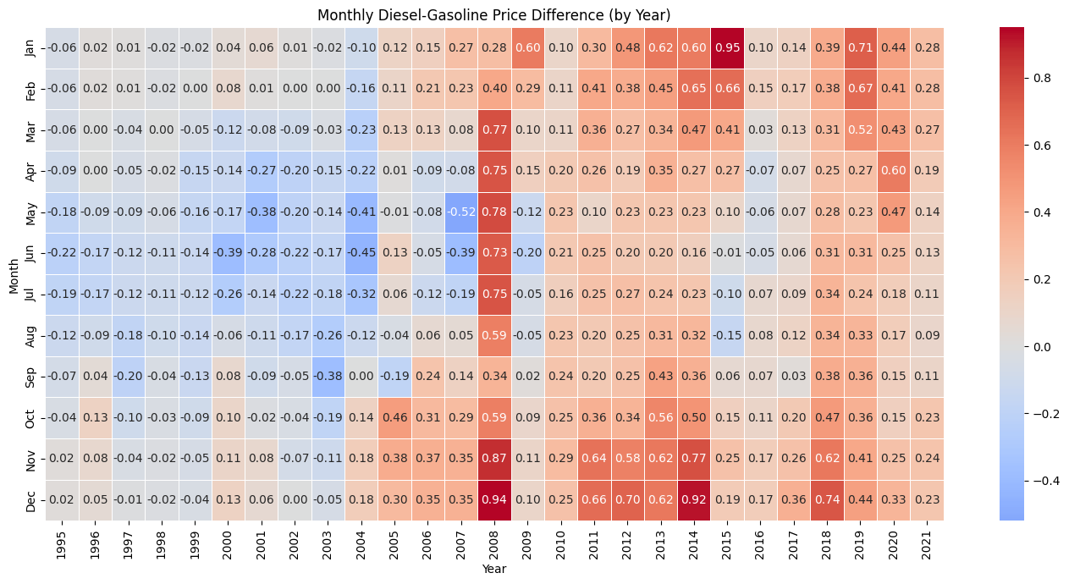
Heatmap showing the difference in price between diesel and gasoline as an absolute value

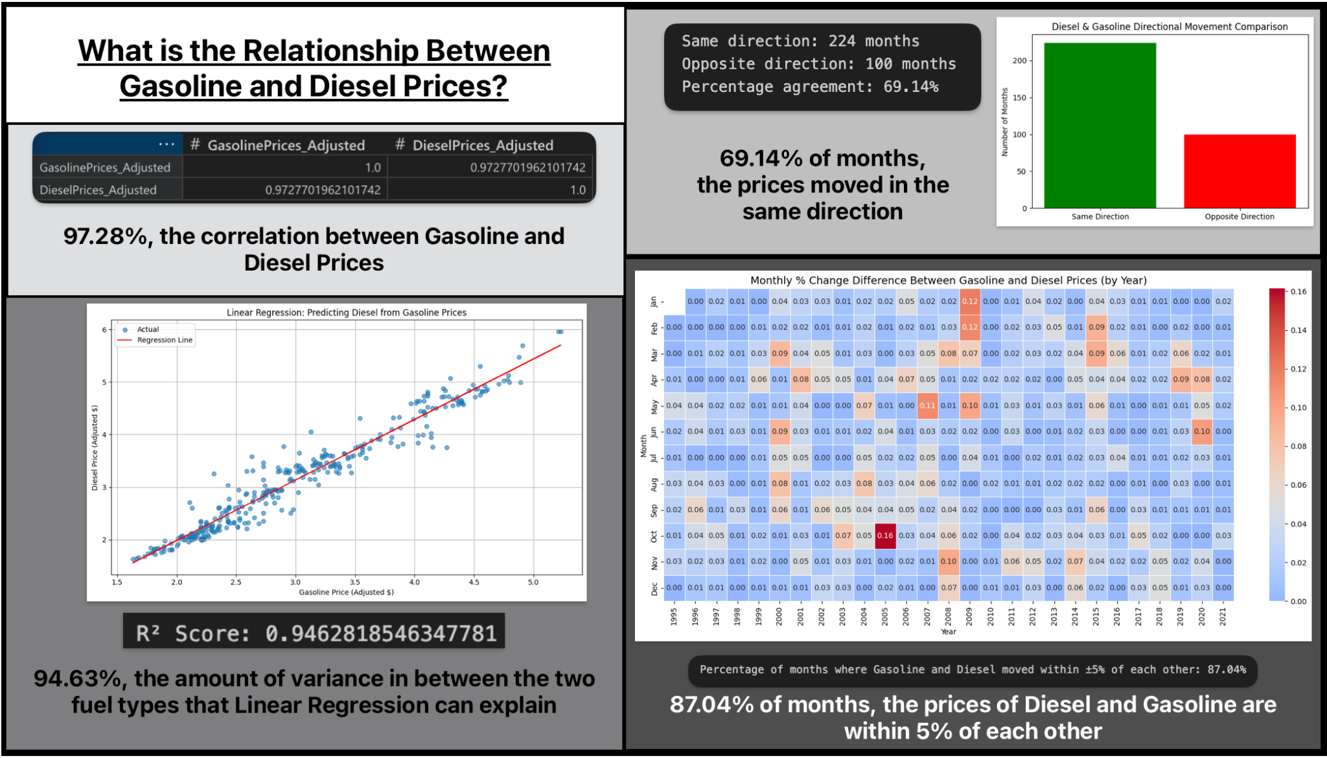
Dashboard built together using our charts and statistics of Gasoline and Diesel prices in relation to one another

Link to GitHub for the Question 2 Notebook with the code, charts, and outputs

Discussion:

As we nearly predicted in our proposal, the results from our analysis showed that gasoline and diesel prices move in very similar ways but not exactly the same ways. This can be explained by the fact that while they are not substitutes for one another, they are affected by the exact same external pressures and forces such as politics and global events. The correlation and regression model can be interpreted to say that they are nearly identical but if you use the metric of whether the month-to-month change in direction was the same, you find only about 2/3rds of the months move in the same direction. Despite that, for most months in the 25 years explored, gasoline and diesel prices remained within 5% of each other. There is an interesting change in trend since 2007/2008 however. It used to be that gasoline and diesel prices were nearly identical or that gasoline was slightly cheaper. In 2008, that trend changed so that diesel prices have become consistently more than gasoline prices.

Link to GitHub Repository for entire code, notebooks, charts, guidelines, etc.

Data Citations:
- 1. U.S. Bureau of Labor Statistics. (n.d.). Consumer Price Index for All Urban Consumers: All Items (CPIAUCSL) [Data set]. Federal Reserve Bank of St. Louis. Retrieved October 31, 2025, from https://fred.stlouisfed.org/series/CPIAUCSL
- 2. U.S. Energy Information Administration. (n.d.). U.S. Product Supplied of Finished Motor Gasoline (Thousand Barrels per Day) [Data set]. U.S. Department of Energy. Retrieved October 31, 2025, from https://www.eia.gov/dnav/pet/pet_cons_psup_a_epm0f_vpp_mbbl_m.htm
- 3. U.S. Energy Information Administration. (n.d.). U.S. All Grades All Formulations Retail Gasoline Prices (Dollars per Gallon) [Data set]. U.S. Department of Energy. Retrieved October 31, 2025, from https://www.eia.gov/dnav/pet/pet_pri_gnd_dcus_nus_m.htm
- 4. U.S. Department of Transportation, Bureau of Transportation Statistics. (n.d.). Production, production shares, and production-weighted fuel economies of new domestic and imported automobiles [Data set]. Retrieved October 31, 2025, from https://www.bts.gov/content/productions-production-shares-and-production-weighted-fuel-economies-new-domestic-and
- 5. U.S. Department of Transportation, Bureau of Transportation Statistics. (n.d.). Automobile profile [Data set]. Retrieved October 31, 2025, from https://www.bts.gov/content/automobile-profile

Acknowledgement of use of Generative AI Tools:
ChatGPT(GPT-5) by OpenAI was used to assist in completing this project. It was used to assist with the development of models and charts, guidance on ideas for improvement, and to assist in debugging code. In the final report it was used for editing, clarification of topics, and formatting.

OpenAI. (2025). ChatGPT (GPT-5) [Large language model]. Retrieved December 10, 2025, from https://chat.openai.com/

